[**Install Nuget package in Visual Studio 2012, 2013, 2015**](https://www.aspsnippets.com/Articles/Install-Nuget-package-in-Visual-Studio-2012-2013-2015.aspx)

Need Help?

Our Support Team is here to help.

[Ask Question](http://aspsnip.pet/query)

**[FaceBook](http://www.facebook.com/ASPSnippets)** **[Twitter](http://twitter.com/intent/follow?source=followbutton&variant=1.0&screen_name=aspsnippets)** **[RSS](https://www.aspsnippets.com/Rss.ashx)** **[Instagram](http://instagram.com/aspsnippets)** **[Youtube](http://www.youtube.com/c/ASPSnippetsChannel?sub_confirmation=1)**

[FaceBook](https://www.facebook.com/sharer/sharer.php?u=https%3a%2f%2fwww.aspsnippets.com%2fArticles%2fInstall-Nuget-package-in-Visual-Studio-2012-2013-2015.aspx)  
[Share on Twitter](https://twitter.com/share?url=https%3a%2f%2fwww.aspsnippets.com%2fArticles%2fInstall-Nuget-package-in-Visual-Studio-2012-2013-2015.aspx&text=Install%20Nuget%20package%20in%20Visual%20Studio%202012,%202013,%202015)

 13 Oct 2016  [Mudassar Khan](https://www.aspsnippets.com/Authors/Mudassar-Khan.aspx) [1](https://www.aspsnippets.com/Articles/Install-Nuget-package-in-Visual-Studio-2012-2013-2015.aspx#comments) Comments  19043 Views

[ASP.Net](https://www.aspsnippets.com/Categories/ASP.Net.aspx)  [jQuery](https://www.aspsnippets.com/Categories/jQuery.aspx)  [Visual Studio](https://www.aspsnippets.com/Categories/Visual-Studio.aspx)  [MVC](https://www.aspsnippets.com/Categories/MVC.aspx)

**Here Mudassar Ahmed Khan has explained a tutorial with an example, how to install Nuget package in Visual Studio 2012, 2013, 2015.  
This article will illustrate how to install Nuget package in Visual Studio 2012, 2013, 2015 by installing System.Web.Optimization DLL reference in Visual Studio.**

[Download Free Word/PDF/Excel API](https://www.aspsnippets.com/Redirect.aspx?AdId=10567&RedirectUrl=https%3A%2F%2Fwww.e-iceblue.com%2FIntroduce%2Fspire-office-for-net-free.html%3Faff_id%3D91)

In this article I will explain a tutorial with an example, how to install Nuget package in Visual Studio 2012, 2013, 2015.

This article will illustrate how to install Nuget package in Visual Studio 2012, 2013, 2015 by installing System.Web.Optimization DLL reference in Visual Studio.

**Adding System.Web.Optimization DLL reference in ASP.Net MVC project**

Following are the steps to install the System.Web.Optimization DLL from Nuget.

1. First step is to start the Package Manager Console window by clicking View menu then Other Windows and finally Package Manager Console.

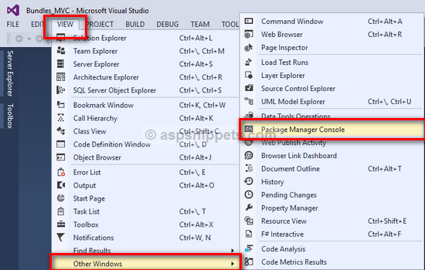

2. In the Package Manager Console window, type the following command and press Enter key and the package will start installing.

**Install-Package Microsoft.AspNet.Web.Optimization**

**Note**: You can also get the latest DLL version and its command from [Microsoft ASP.NET Web Optimization... 1.1.3](https://www.nuget.org/packages/Microsoft.AspNet.Web.Optimization/).

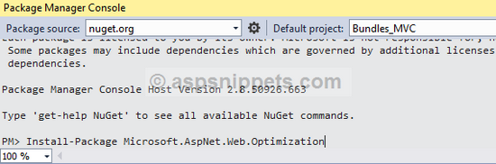

Once the package is installed, a success message will be displayed.

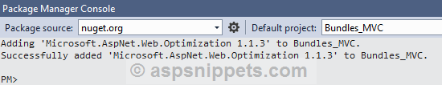

[Download Free Word/PDF/Excel API](https://www.aspsnippets.com/Redirect.aspx?AdId=10567&RedirectUrl=https%3A%2F%2Fwww.e-iceblue.com%2FIntroduce%2Fspire-office-for-net-free.html%3Faff_id%3D91)